NinSk0 = 

NinSk1 = 

NinSk2= 

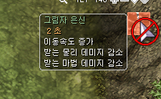

NinSk3=

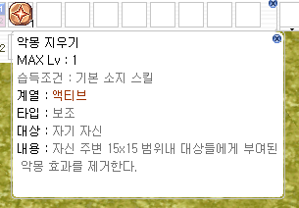

NinSk4= 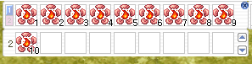

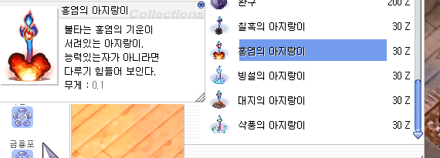

NinSk5=

NinSk6= 

NinSk7=

NinSk8=

NinSk9=

NinSk10=

NinSk11=

NinSk12=

NinSk13= 

NinSk14b= 

NinSk15=

NinSk16=

NinSk17=

NinSk18=

NinSk19=